EXPLORATORY DATA ANALYSIS (EDA) AND TEXT PREPROCESSING ON IMDB MOVIE REVIEWS DATASET

Yuva Internship-Week 1 Report

Submitted By

Satya Sai Bhagya Lakshmi Budidi
B.Tech - Artificial Intelligence
Vignan Institute of engineering for Women

Internship Details

Internship Name: Yuva internship
Week: Week 1
Task Title: Exploratory Data analysis & Preprocessing in NLP
Dataset: IMDB Movie Reviews Dataset
Tools used: Google colab,Python,Pandas,NumPy,Matplotlib,Seaborn,NLTK,Scikit-learn,Wordcloud

Submission Date: 29-07-2027
TABLE OF CONTENTS

1. Introduction

- Overview of NLP
- What is EDA?
- Importance of Text Preprocessing
- Purpose of the Study

2. Objective

3. Dataset Overview

- Dataset Description
- Dataset Source
- Features Description
- Dataset Statistics

4. Exploratory Data Analysis (EDA)

- Importing Libraries
- Loading Dataset
- Dataset Inspection (head(), tail())
- Dataset Shape
- Column Names
- Dataset Information
- Statistical Summary
- Missing Values
- Duplicate Values
- Sentiment Distribution
- Review Length Analysis
- Word Frequency Analysis
- Top 20 Frequent Words
- Word Cloud
- Bigram Analysis
- Trigram Analysis

5. Text Preprocessing

- Lowercase Conversion
- HTML Tag Removal
- Punctuation Removal
- Number Removal
- URL Removal
- Stopword Removal
- Tokenization
- Lemmatization

6. Data Visualization

- Bar Chart
- Pie Chart
- Histogram
- Word Cloud
- Frequency Plot

7. Challenges Encountered

8. Key Insights

9. Conclusion

10. References

1. Introduction

1.1 Overview of Natural Language Processing (NLP)

Natural Language Processing (NLP) is a branch of Artificial Intelligence (AI) that enables computers to understand, process, and analyze human language. It is widely used in applications such as sentiment analysis, chatbots, language translation, spam detection, and text classification.

1.2 What is Exploratory Data Analysis (EDA)?
Exploratory Data Analysis (EDA) is the process of understanding a dataset before building machine learning models. It helps identify data patterns, missing values, duplicate records, and relationships using statistical methods and visualizations

1.3 Importance of Text Preprocessing
Text preprocessing improves the quality of textual data by removing unwanted elements such as HTML tags, punctuation, numbers, URLs, and stopwords. It also includes tokenization and lemmatization, making the text suitable for NLP tasks.

1.4 Purpose of the Study
The purpose of this study is to perform Exploratory Data Analysis (EDA) and text preprocessing on the IMDb Movie Reviews dataset. The study analyzes the dataset, cleans the text, visualizes important patterns, and prepares the data for future NLP applications such as sentiment analysis.

2. Objective

2.1 Task Objectives

The primary objectives of this task are:

- To explore the IMDb Movie Reviews dataset using Exploratory Data Analysis (EDA).
- To understand the structure and characteristics of the dataset.
- To identify missing values, duplicate records, and sentiment distribution.
- To analyze review length, word frequency, and common word patterns.
- To preprocess the text using standard NLP techniques.
- To prepare the dataset for future Natural Language Processing and sentiment analysis tasks.

2.2 Expected Outcomes

At the end of this task, the following outcomes are expected:

- A clear understanding of the dataset through EDA.
- A cleaned and preprocessed text dataset.
- Visual representations of important patterns and trends.
- Identification of common words, bigrams, and trigrams.
- A dataset ready for further NLP and machine learning applications.

3. Dataset Overview

3.1 Dataset Description
The IMDb Movie Reviews Dataset is a publicly available dataset used for sentiment analysis and other Natural Language Processing (NLP) tasks. It contains movie reviews collected from IMDb, where each review is labeled as either positive or negative. The dataset is widely used for text classification and sentiment analysis because it provides balanced and high-quality textual data.

3.2 Dataset Source
- Dataset Name: IMDb Movie Reviews Dataset
- Source: Kaggle
- File Name: IMDB Dataset.csv
- Format: CSV (Comma Separated Values)
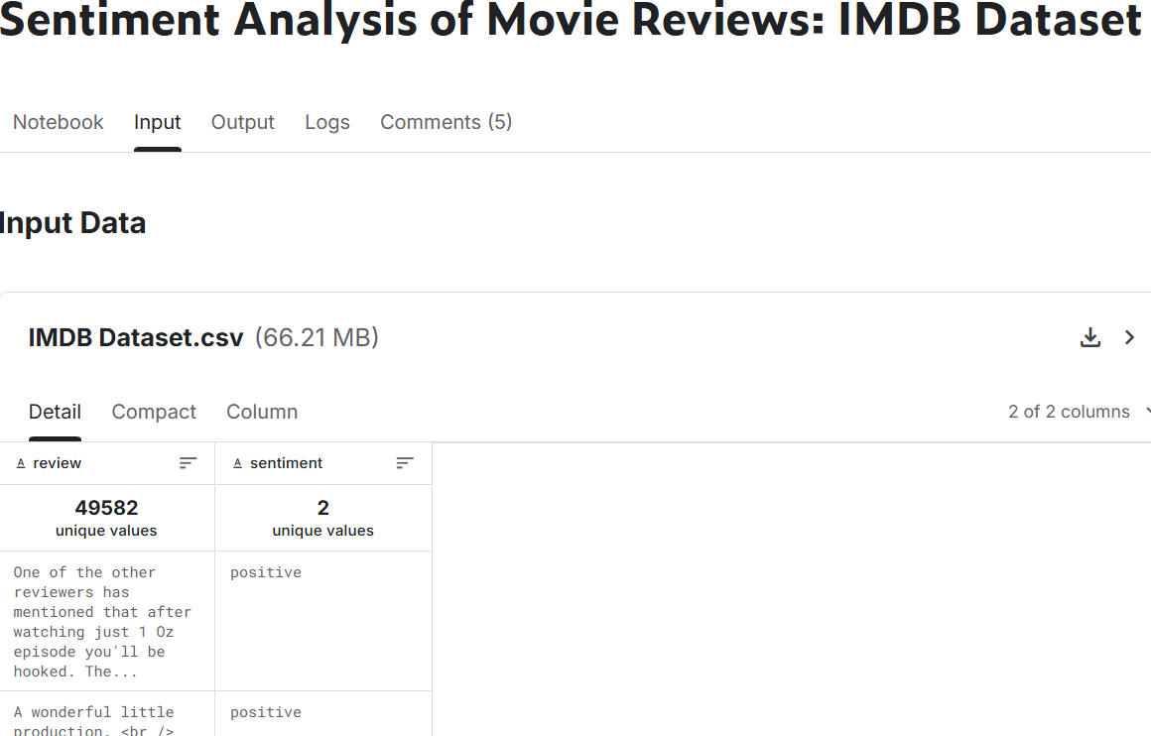

3.3 Features (Columns) Description
The dataset consists of two columns:
Column Name | Description
review | Contains the text of the movie review.
sentiment | Indicates whether the review is positive or negative.

3.4 Dataset Statistics
Attribute | Value
Total Records | 50,000
Total Columns | 2
Positive Reviews | 25,000
Negative Reviews | 25,000
Dataset Type | Text Dataset
Target Variable | sentiment

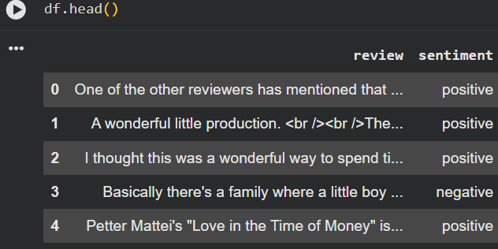

4. Exploratory Data Analysis(EDA)
4.1 Importing Required Libraries
Description:
To perform data analysis and text preprocessing, the required Python libraries were imported. These libraries provide functionalities for data manipulation, visualization, and Natural Language Processing.
Libraries Used:
Pandas
NumPy
Matplotlib
Seaborn
NLTK
WordCloud
Collections
Re (Regular Expressions)

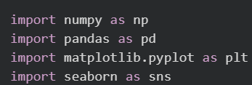
Observation:
All required libraries were successfully imported without errors, enabling data analysis and visualization.

4.2 Loading the Dataset
Description:The IMDb Movie Reviews dataset was loaded into Google Colab using the Pandas read_csv() function. This converted the CSV file into a DataFrame for analysis.

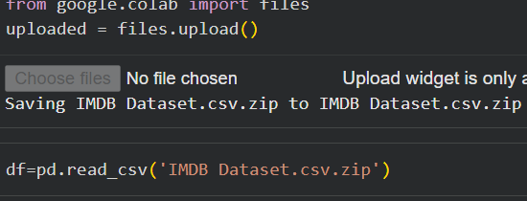
Observation:
The dataset was loaded successfully and is ready for further analysis.

4.3 Displaying the Dataset (head() & tail())
Description:The first and last five records of the dataset were displayed to verify that the dataset was loaded correctly and to understand its structure.
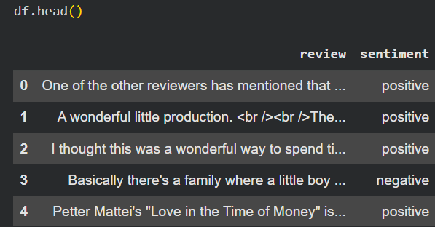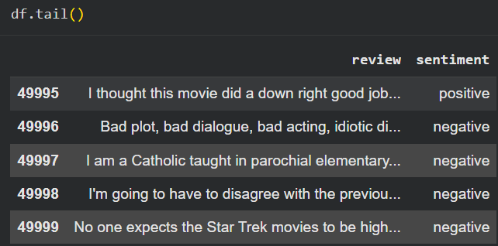

Observation:The dataset contains two columns: review and sentiment. Each review is labeled as either positive or negative.

4.4 Dataset Shape and Dimensions
Description:The shape attribute was used to determine the number of rows and columns in the dataset.

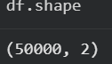
Observation:
The dataset contains 50,000 rows and 2 columns, indicating a sufficiently large dataset for sentiment analysis.

4.5 Column Names
Description:
The column names were examined to understand the dataset structure.
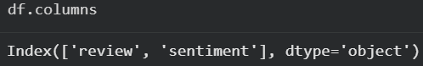
Observation:
The dataset contains two columns:
review
sentiment
4.6 Dataset Information (info())
Description:
The info() function was used to examine the data types and verify whether any missing values exist.
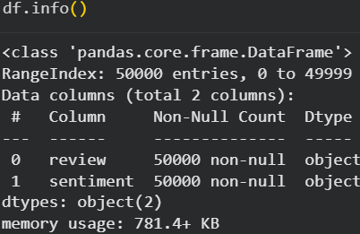

Observation:
Both columns have the object data type, and no missing values were found.

4.7 Statistical Summary (describe())
Description:
The describe() function was used to summarize the dataset and provide basic statistical information.
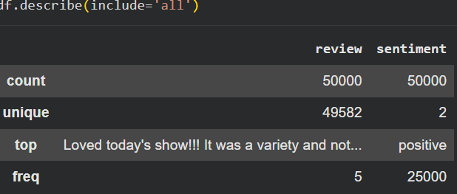
Observation:
The summary shows the number of reviews, unique values, most frequent entries, and their occurrence counts.

4.8 Missing Values Analysis
Description:
The dataset was checked for missing values using the isnull().sum() function.
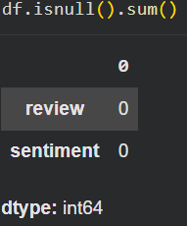
Observation:
No missing values were found, indicating that the dataset is complete.

4.9 Duplicate Values Analysis
Description:
The dataset was examined for duplicate records using the duplicated().sum() function.
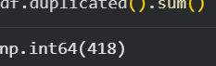
Observation:
The duplicate records identified were noted and can be removed if necessary to improve data quality.

4.10 Sentiment Distribution Analysis
Description:
The distribution of positive and negative reviews was analyzed to understand the balance of the dataset.
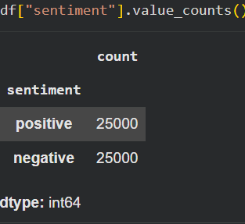

Observation:
The dataset contains nearly equal numbers of positive and negative reviews, making it balanced for sentiment analysis.

4.11 Review Length Analysis
Description:The length of each review was calculated to study the distribution of review sizes.

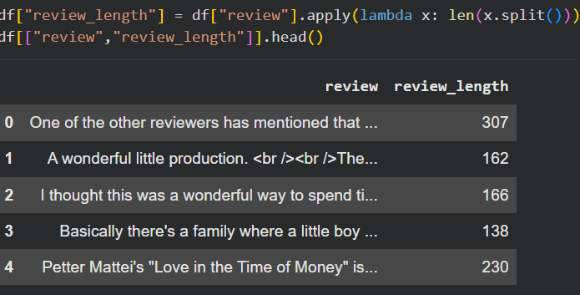
Observation:

Most reviews have a moderate length, while a smaller number are significantly longer.

4.12 Word Frequency Analysis
Description:
The most frequently occurring words were identified after preprocessing.

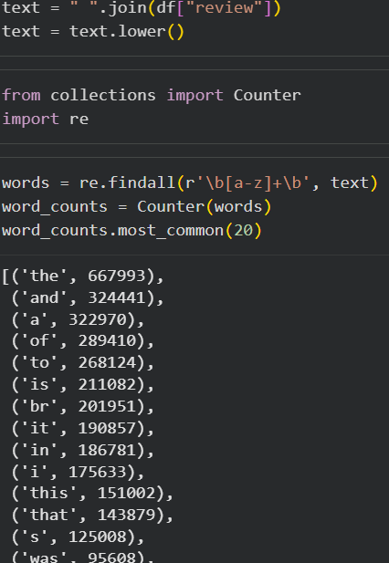
Observation:
The frequency analysis highlights the most common words used in movie reviews.

4.13 Top 20 Frequent Words
Description:
The top 20 most frequently occurring words were visualized to identify dominant terms in the dataset.

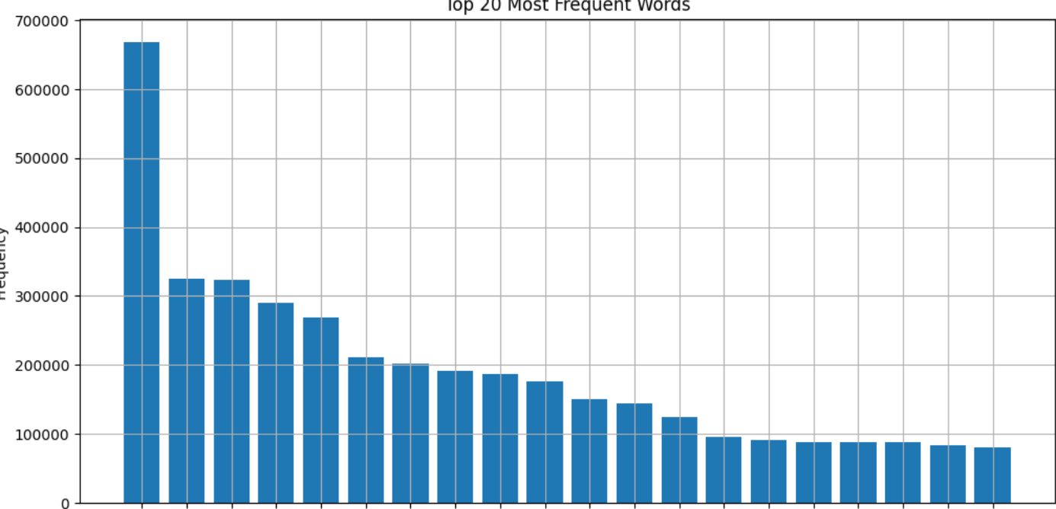
Observation:
These words represent the most commonly used terms after preprocessing.

4.14 Word Cloud Analysis
Description:

A Word Cloud was generated to visualize frequently occurring words in the reviews.


Observation:
Larger words in the Word Cloud indicate higher frequency, providing a quick overview of dominant vocabulary.

4.15 Bigram Analysis
Description:

Bigram analysis identifies the most common pairs of consecutive words in the reviews.
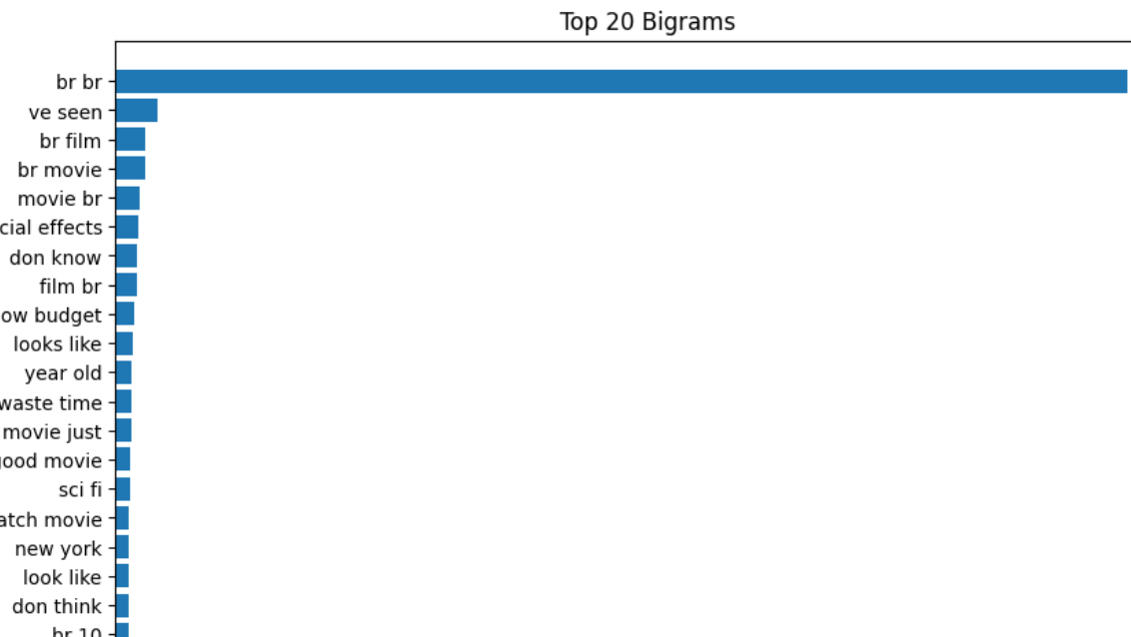

Observation:
The analysis reveals commonly occurring word pairs that provide additional context.

4.16 Trigram Analysis
Description:
Trigram analysis identifies the most common groups of three consecutive words.

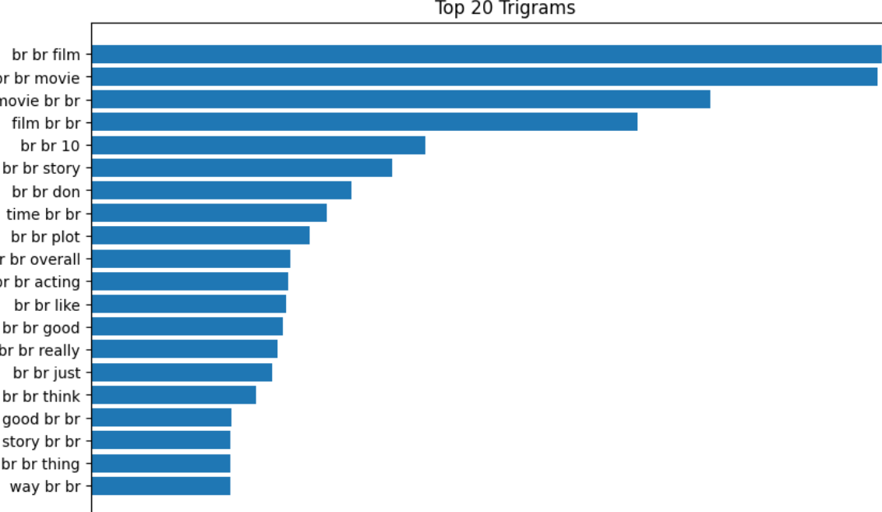
Observation:
Frequently occurring three-word combinations provide deeper insights into review patterns.

5. Text Preprocessing
5.1 Introduction
Description:
Text preprocessing is an essential step in Natural Language Processing (NLP). It involves cleaning and transforming raw text into a structured format that can be easily analyzed by machine learning models. In this project, several preprocessing techniques were applied to improve the quality of the IMDb movie reviews dataset.

5.1 Lowercase Conversion
Description:
All review text was converted into lowercase to ensure consistency and avoid treating the same word with different cases as separate words.
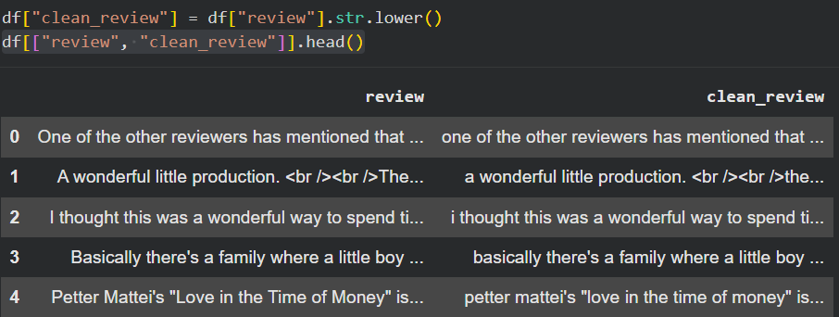

Observation:
All uppercase letters were successfully converted to lowercase, reducing word duplication.

5.2 HTML Tag Removal
Description:

HTML tags such as <br /> were removed using Regular Expressions (re) to clean the review text.
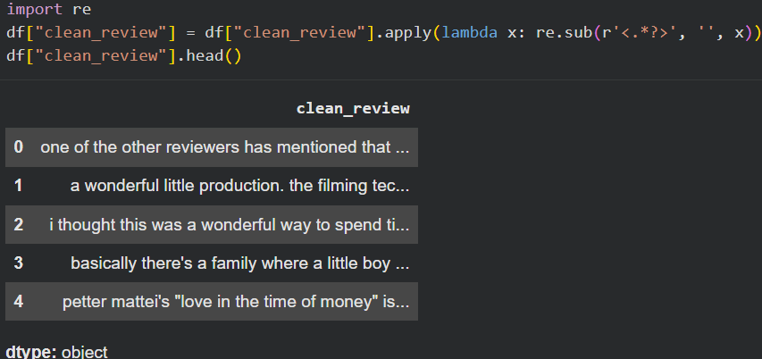

Observation:
The review text became cleaner after removing HTML tags.

5.3 Punctuation Removal
Description:
Punctuation marks such as commas, periods, question marks, and exclamation marks were removed because they do not contribute significantly to sentiment analysis.
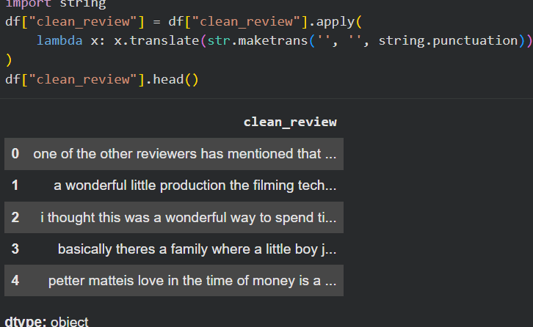

Observation:
Only meaningful words remain after punctuation removal.

5.4 Number Removal
Description:
Numerical values were removed from the reviews as they generally do not contribute to understanding the sentiment.
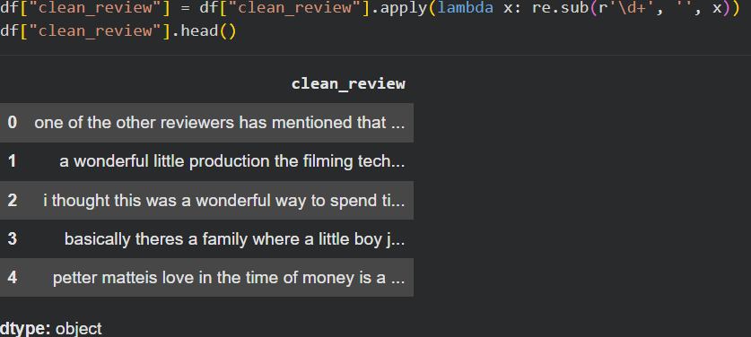
Observation:
The reviews now contain only textual information relevant to analysis.

5.5 URL Removal
Description:
URLs were removed from the reviews using Regular Expressions to eliminate unnecessary information.

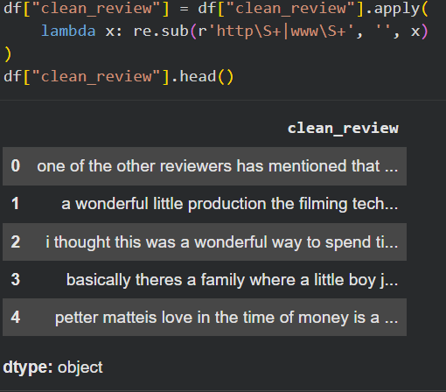
Observation:

Any web links present in the dataset were successfully removed.

5.6 Stopword Removal
Description:
Common English stopwords such as the, is, and, of, and to were removed using the NLTK stopword list to retain only meaningful words.

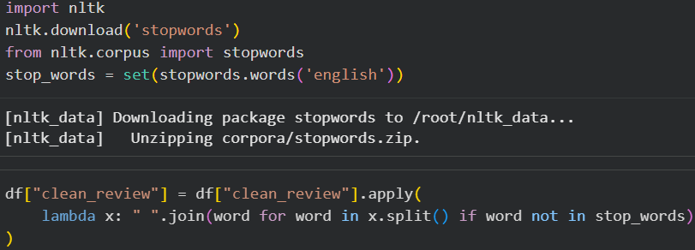

Observation:
The processed text contains more informative words useful for sentiment analysis.

5.7 Tokenization
Description:
Tokenization is the process of splitting each review into individual words called tokens. This is an important preprocessing step in NLP.
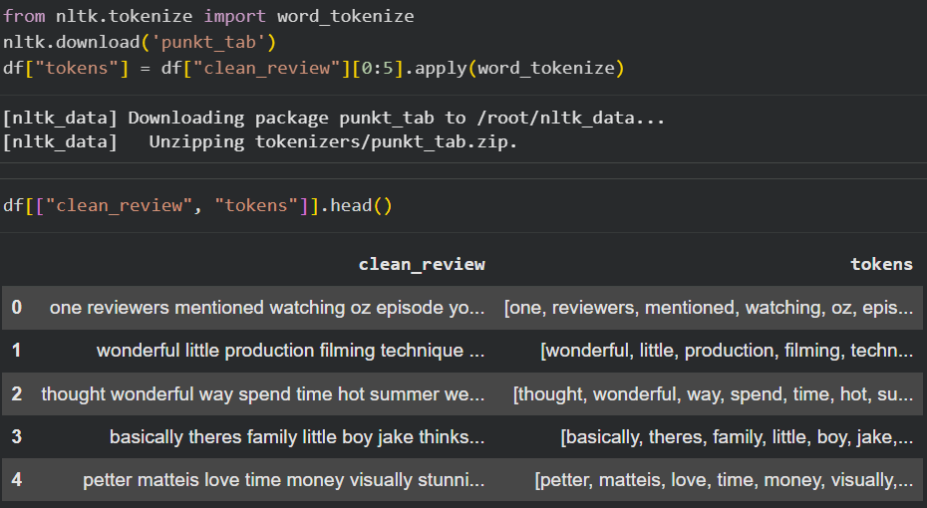

Observation:
Each review was successfully converted into a list of individual words.

5.8 Lemmatization
Description:
Lemmatization converts words into their base or dictionary form, reducing different forms of the same word to a common representation.

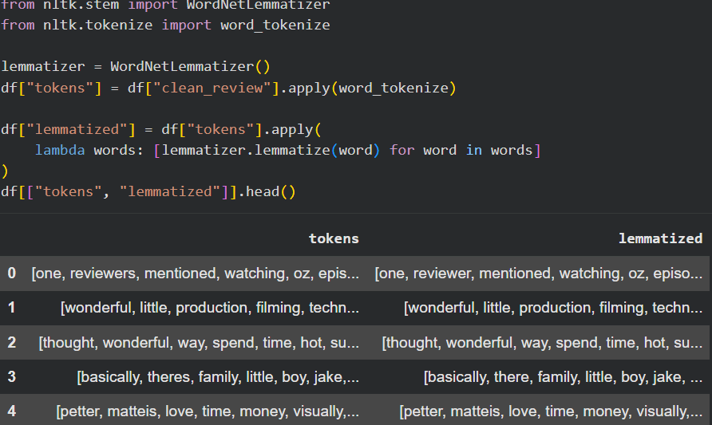

Observation:
Words were converted to their root forms, improving consistency and reducing vocabulary size.

6. Data Visualization
6.1 Introduction
Description:
Data visualization helps present patterns and insights from the dataset in a graphical format. Various charts were created to better understand sentiment distribution, review lengths, and frequently occurring words.

6.1 Bar Chart – Sentiment Distribution
Description:
A bar chart was created to compare the number of positive and negative reviews.

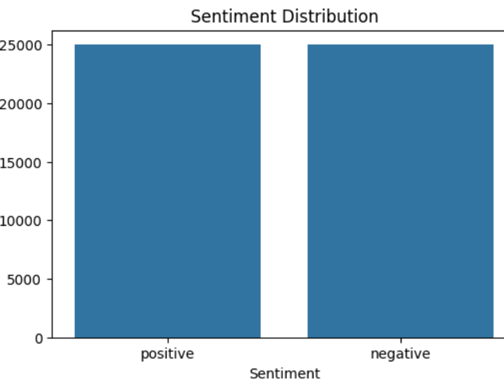

Observation:

The dataset contains nearly equal numbers of positive and negative reviews, making it balanced.

6.2 Histogram – Review Length
Description:
A histogram was plotted to analyze the distribution of review lengths.

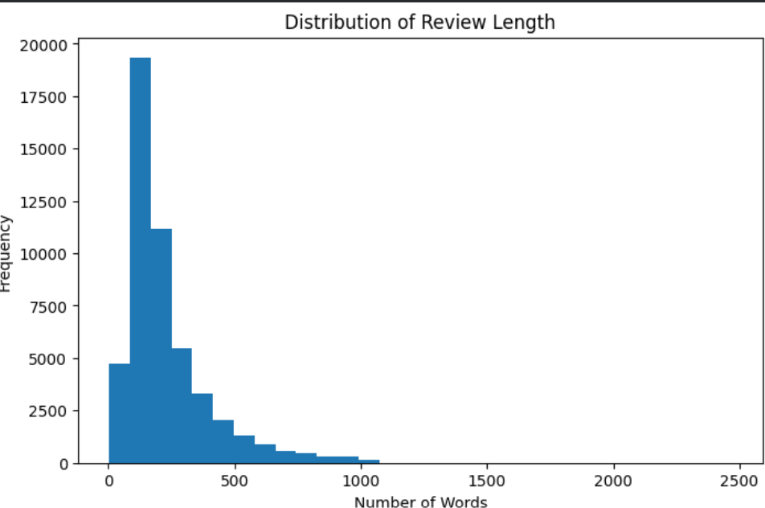
Observation:
Most reviews have a moderate length, while only a few reviews are exceptionally long.
6.3 Pie Chart – Sentiment Distribution
Description:
A pie chart was used to visualize the percentage of positive and negative reviews.
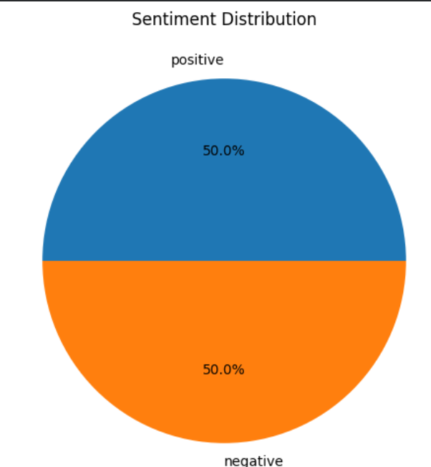

Observation:
Both sentiment categories occupy almost equal portions of the dataset.

6.4 Word Cloud
Description:
A Word Cloud was generated to visualize the most frequently occurring words in the dataset.
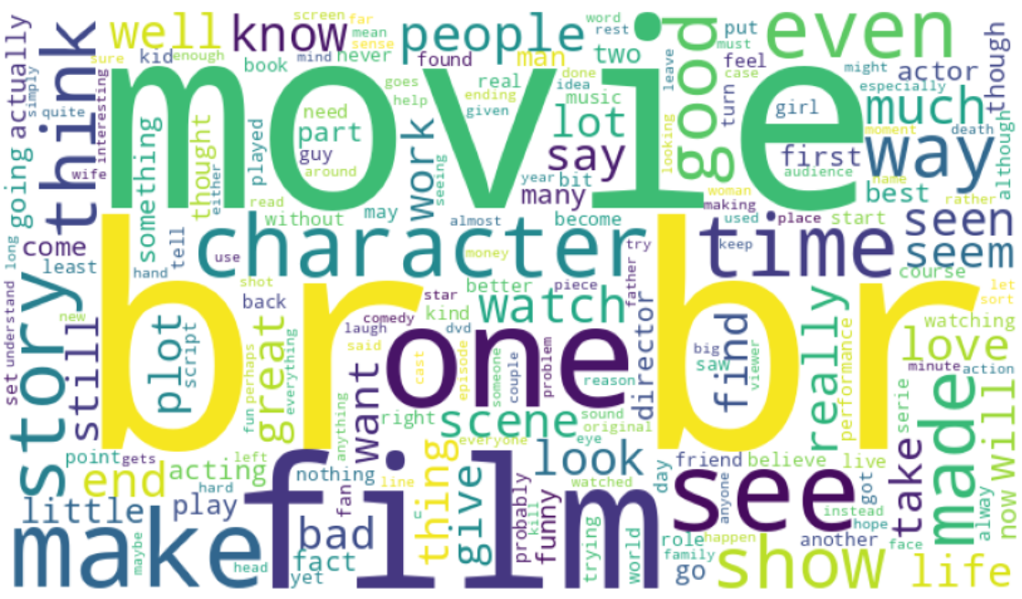
Observation:
Frequently occurring words appear larger, providing a quick overview of common vocabulary.

6.5 Frequency Plot (Top 20 Words)
Description:
A frequency plot was created to display the top 20 most frequently occurring words after preprocessing.


Observation:
The plot highlights the most common meaningful words present in the reviews.

7. Challenges Encountered
- Challenges Faced
- Understanding NLP preprocessing techniques.
- Removing HTML tags and unwanted characters.
- Selecting appropriate visualization methods.
- Generating meaningful word frequency analysis.
- Understanding tokenization and lemmatization.
- Solutions Implemented
- Used Python Regular Expressions for cleaning text.
- Used the NLTK library for preprocessing.
- Applied visualization libraries such as Matplotlib and WordCloud.
- Verified outputs after each preprocessing step.

8. Key Insights
- The IMDb dataset contains 50,000 movie reviews.
- The dataset is balanced with positive and negative sentiments.
- No missing values were found.
- Preprocessing significantly improved the quality of the text.
- Word Cloud and frequency analysis identified commonly used words.
- Tokenization and lemmatization prepared the data for future NLP tasks.
9. Conclusion

- This project successfully performed Exploratory Data Analysis (EDA) and text preprocessing on the IMDb Movie Reviews dataset. Various preprocessing techniques were applied to clean the textual data, while visualizations provided meaningful insights into sentiment distribution and word usage. The processed dataset is now suitable for future Natural Language Processing tasks such as sentiment analysis and text classification.

10. References
- IMDb Movie Reviews Dataset – Kaggle
- Pandas Documentation
- NumPy Documentation
- Matplotlib Documentation
- Seaborn Documentation
- NLTK Documentation
- WordCloud Documentation

